**PRACTICAL: 2**

**AIM:** Install and configure the following development setup tools to implement

Blockchain development.

* Metamask (Wallet)
* Ganache Local Private Blockchain Network
* Go-Ethereum (Geth) Client
* Truffle framework
* Hardhat framework

Study and configure all testnets available in Metamask and also setup custom network using Ganache.

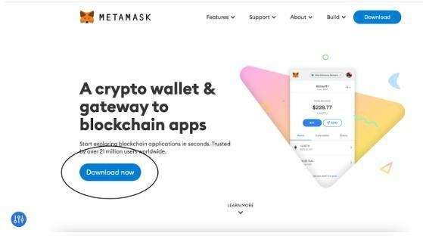



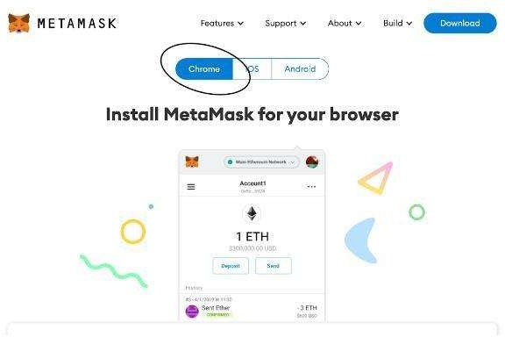



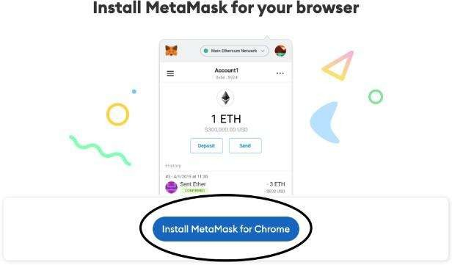



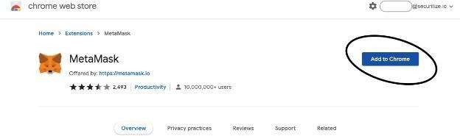

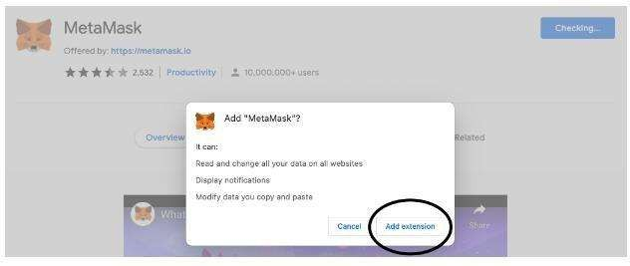



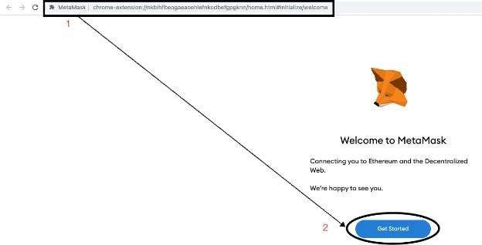



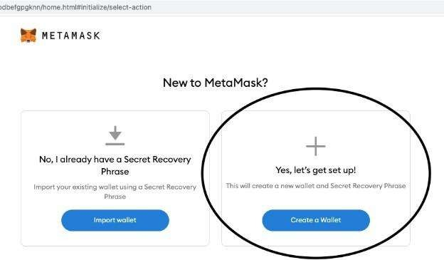



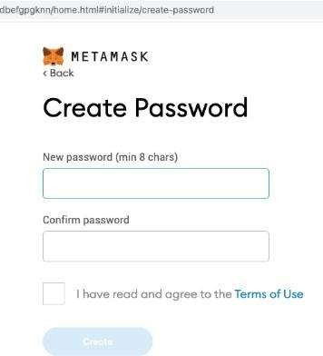





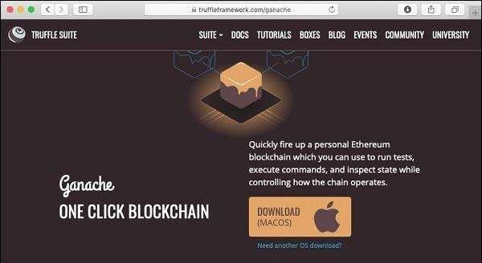



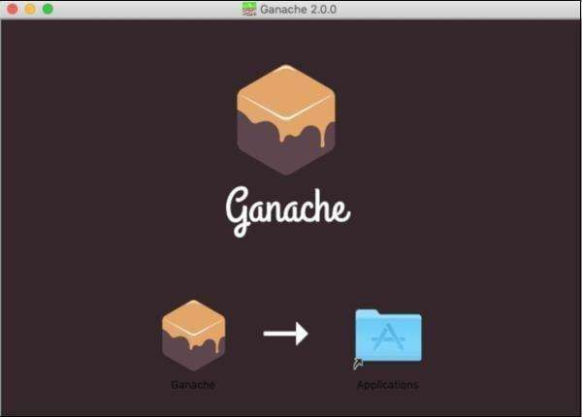

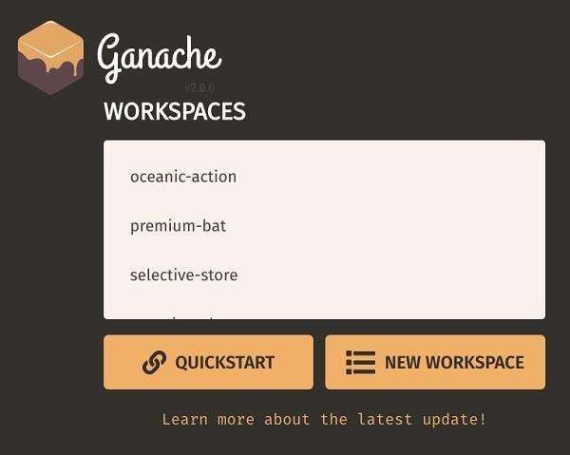



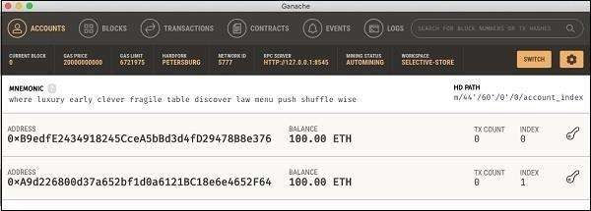



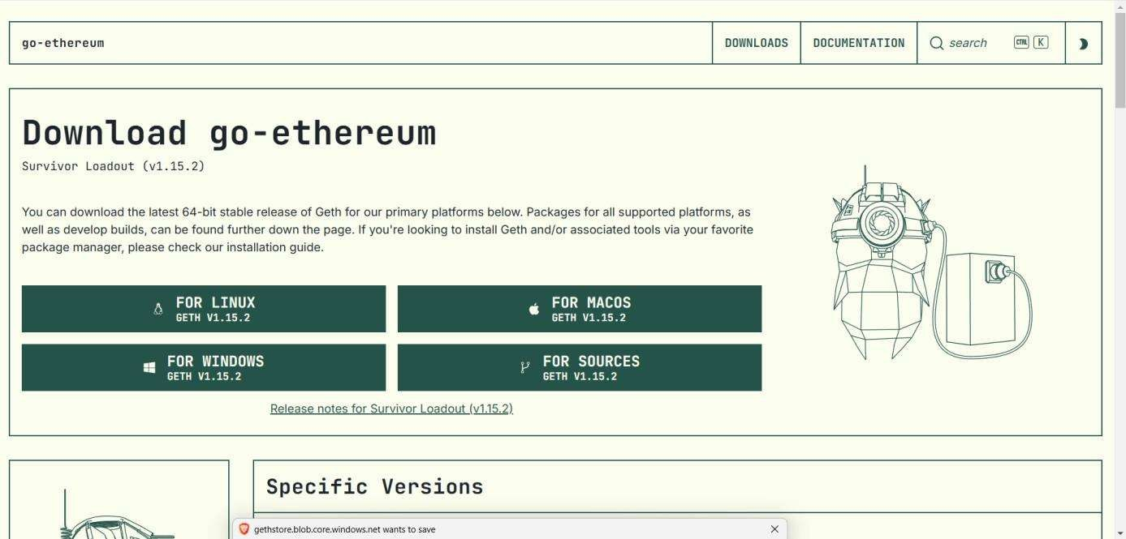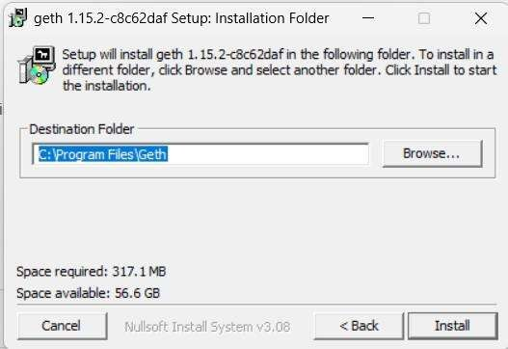



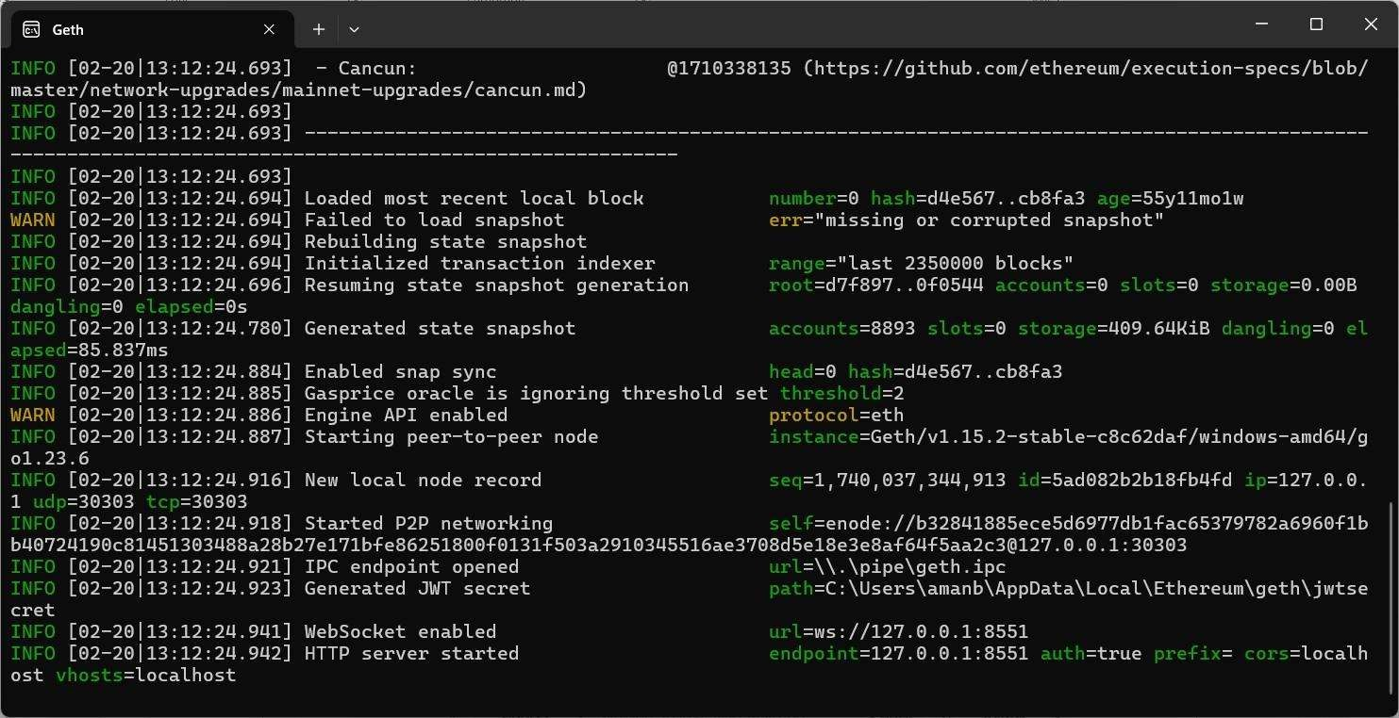



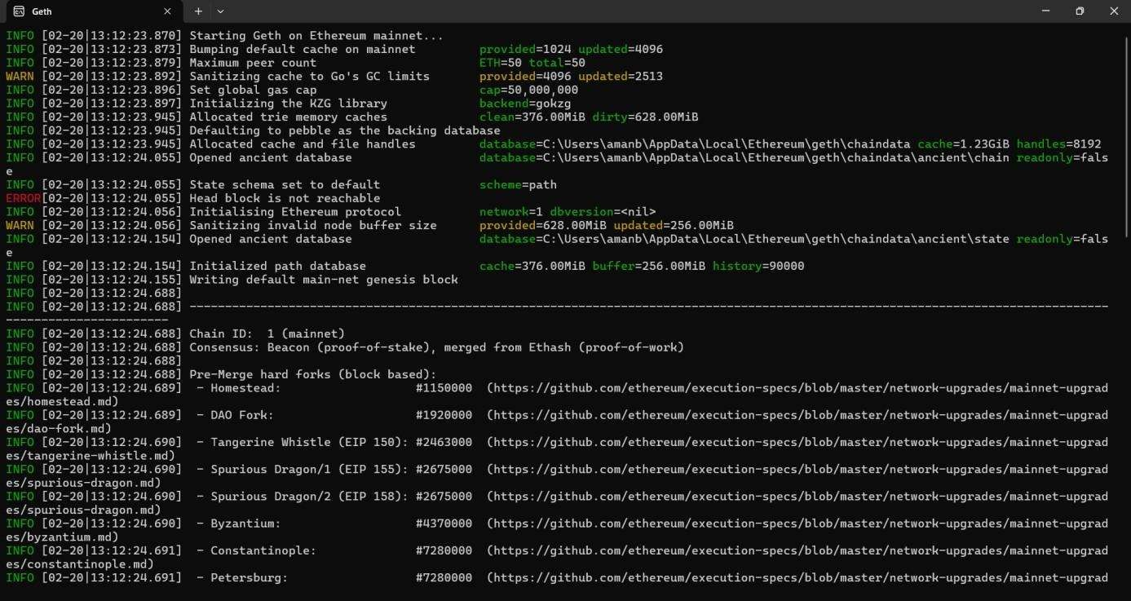

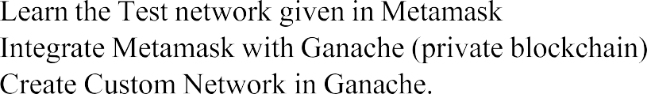





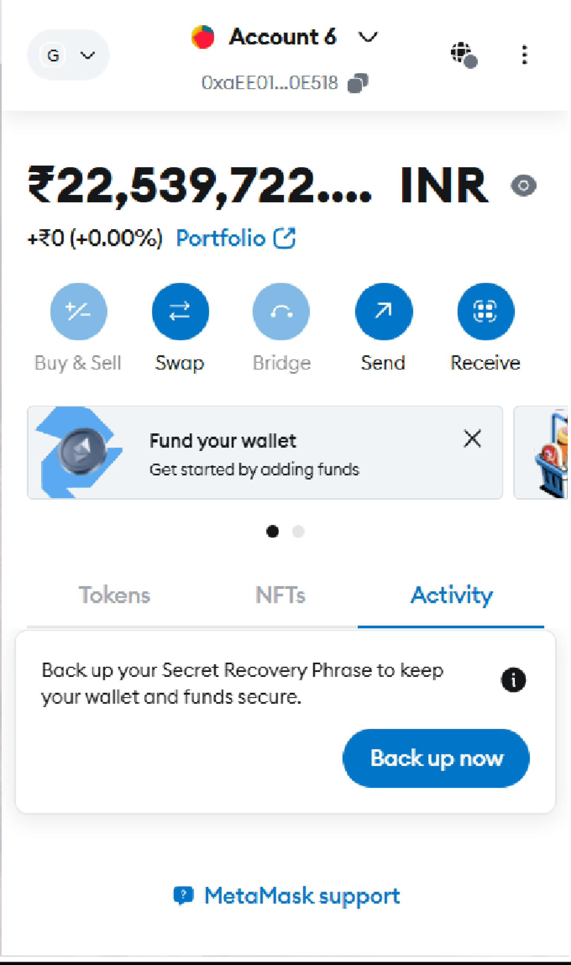



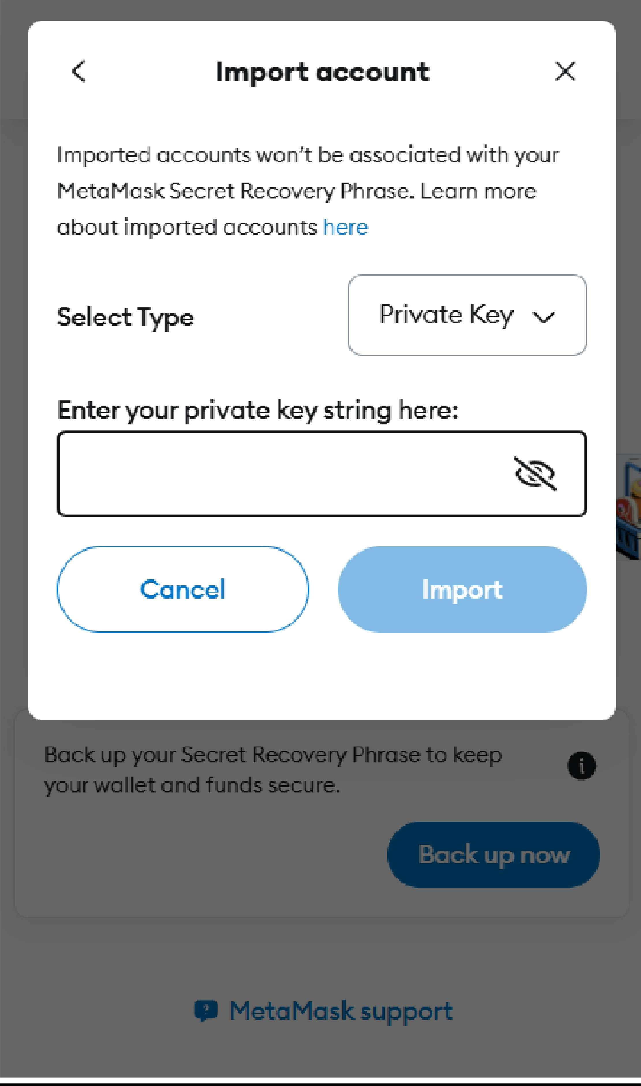

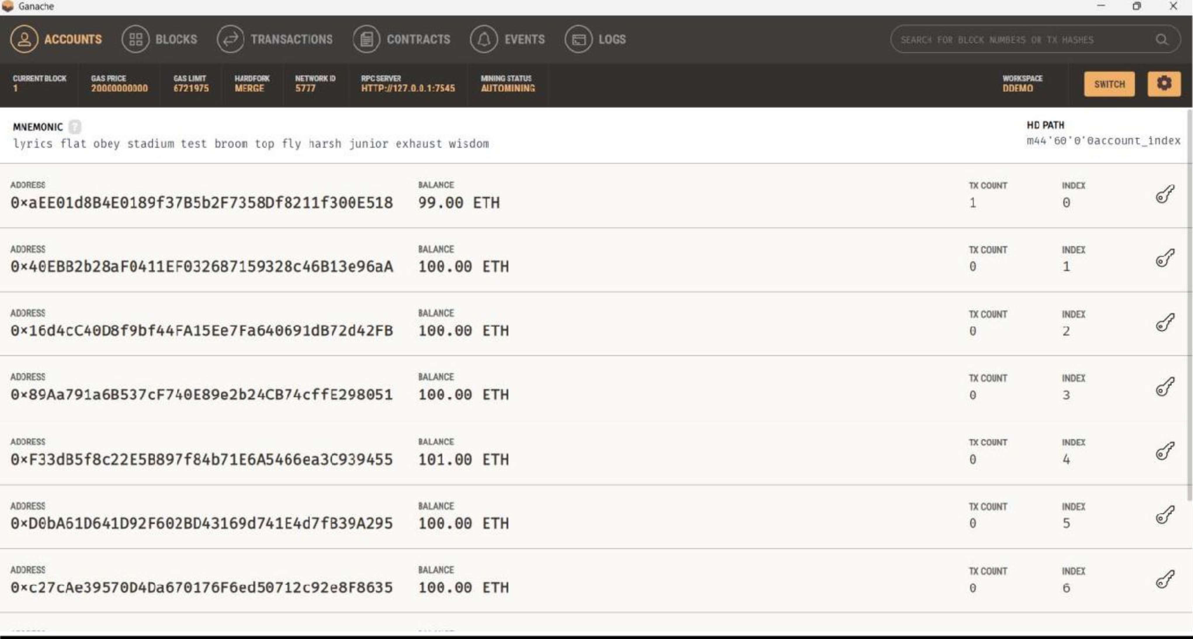

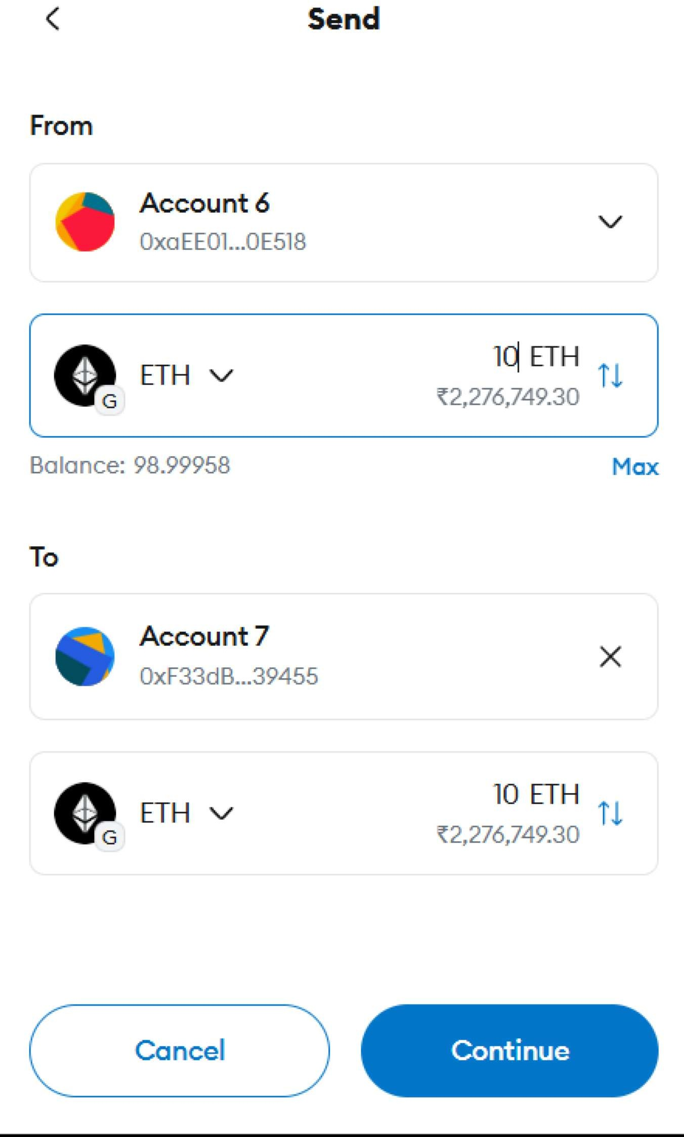

**LEARNING OUTCOME:**

Setting up blockchain development tools is crucial for creating Ethereum-based decentralized applications. Tools like Metamask (for wallet management), Ganache (for a local Ethereum blockchain), Go-Ethereum (Geth) (for node management), Truffle (for compiling and deploying smart contracts), and Hardhat (for advanced contract development) are installed and configured to streamline development. In Metamask, developers set up and explore test networks, such as Sepolia and Goerli, for contract testing. Using Ganache, developers create and manage custom local blockchain networks, simulating real-world Ethereum environments. These tools provide hands-on experience with Ethereum-based blockchain frameworks, allowing developers to effectively build, test, and deploy smart contracts and decentralized applications.